COMPANY PROFILE

AADI MediTour is a leading medical tour facilitator offering end-to-end solutions to patients who travel to countries abroad for medical care and treatment. Our team is constituted of experts, with every member keen to provide each and every patient with the most effective world class treatments and other options in a thoroughly professional manner. With a highly competent and experienced medical panel, extensive alliances with world-class medical centres, elaborate network of logistics and dedicated personnel to fulfil patient's various needs, we endeavour to make you feel at home when you are away from your home.

We are the only medical tourism provider that provides services to patients in every part of the world. We are dedicated to deliver a broad array of services to all patients, i.e. the ‘in-bound’ patients who come to India, ‘intra-bound’ patients who travel within India and ‘inter-bound’ patients who travel to other countries for medical treatment. In addition, AADI MediTour is the only Indian provider of services, such as medical counselling, travel arrangements, emergency services, etc., to patients who are based in the NCR (National Capital Region of Delhi) and want to avail treatment in NCR.

Established in September 2009, our company has grown and expanded its footprints in other Indian states, including Bihar, J&K, UP, Maharashtra, and other countries, viz., US, EU-5, Iraq, Afghanistan, Middle Eastern, Nigeria, Uganda, Kenya and Nepal. In addition to providing medical care & treatment in India, we are assisting patients receive best-in-class affordable medical services in Thailand, South Africa, and Turkey.

With an in-house medical care facility – CHIKITSA Multispecialty Hospital – company is associated with the top medical specialists, who evaluate every case in detail before deciding upon a course of treatment. In addition, the company has associations with the leading medical centres, which are well furnished with state-of-the-art technology and are well equipped to give complete support to patients and their families.

AADI MediTour has successfully assisted more than 300 patients across various medical indications, including cardiac, cosmetic, joint replacements, respiratory, spinal problems, kidney problems, gastrointestinal problems, weight-loss, dental, transplants, neurological, ENT, eye care, cancer, and other areas that require medical intervention. Also, with the help of our remote service – Doctor@Net – we have assisted numerous patients, both across India and around the world, to receive Second Opinion from our competent doctors, without actually visiting the doctor in-person.

Besides the core services of medical facilitation, AADI MediTour has diversified to offer other medical services, viz., Medical Recruitment, Education & Research and Healthcare Consultancy.

Our Philosophy: ‘Home Away From Home’
AADI MediTour provides a ‘human touch’ and ensures that every patient gets the best-in-class facilities during the course of treatment. We emphasize in providing best services, in addition to serving patients with utmost warmth and respect.

Our Mission: ‘Provide Affordable Medical Care to the World’
Is your doctor too busy to give you an appointment in the near future? Or do you find it too costly to pay for the treatment required for your illness? Is there no medical centre or hospital in your vicinity to provide the treatment required by you? Or you don’t know which doctor to go to? Then surely we are right people to take care of your problem. At AADI MediTour, we are prepared to provide you the best treatment by the best doctors with latest procedures at state of the art medical centres equipped with the most modern equipment.

Our Policy: ‘Trust and Transparency’
What matters at AADI MediTour is the honour for word. We are always trying to deliver the maximum with honesty and sincerity. Although, in the medical field, response to a certain procedure and recovery of the patient varies from person to person, we try to provide the best possible projections based on the data provided by the patient.

Our Services
Medical Tourism Services
With a widespread network of the top medical service and logistics providers across the globe, AADI MediTour promises to fulfill a broad spectrum of requirements for both the patients and their accompanying members:

Medical Care – We at AADI MediTour will conduct an informed assessment of the medical condition of the patient and shall provide various options/services that will help her/him navigate in the most comforting and effective manner. We will ensure that every patient attains both medical and personal care that could eventually result in complete satisfaction. AADI MediTour is dedicated to offer a complete medical package that will include:
- Preliminary Case Analysis: This will be carried out before the patient leaves his / her home town for treatment. Our expert panel of doctors will make an initial assessment of the case on the basis of the documents provided by you, aided by interactions with you to decide upon the appropriate medical treatment procedure. Discussion with the doctor(s) at either end may also be arranged in case required via email or webcam
- Available Options for Treatment: Different sets of packages shall be offered to the patient varying on account of factors, such as the cost of medical procedure & class of hospital, lodging & other personalized services
- Diagnostic / Preliminary Tests: Our in-house medical center – CHIKITSA Multispecialty Hospital – provides world class diagnostic and pathological facilities. Besides, we also have tie-ups with CAP accredited diagnostic & pathology labs that will ensure effective preliminary testing at affordable prices
- Hospitalization: AADI MediTour will make the best efforts to ensure that your admission and stay in the hospital / medical care facility of your choice is smooth and is properly taken care of with a personal touch
- Emergency Services: In emergency cases we can arrange for helicopter ambulances to pick up patients. In critical cases, we arrange ambulances to pick-up from the airport
- Doctor@Home: In special cases, for patients requiring long post-operative stay, we can arrange doctors who could visit at the guest houses/hotels
- Nursing: We also arrange nurses who could take care of the basic needs of patients, who are unable to do so
- Follow-up Care: Utmost care is taken at AADI to ensure full and the best post-treatment services, both during and after your stay
- Non-Conventional Treatments: We also offer packages for non-conventional therapies, such as Ayurveda, Yoga, Naturopathy, Aroma Therapy, Flower Therapy, and many more, which will result in quicker healing and rejuvenation

Travel, Documentation & Lodging – We at AADI MediTour are dedicated to provide our clients with the most comfortable traveling and accommodation options in any given price range. With the best available options, we provide a complete service package that includes:
- Value Accommodation: We will provide you with various options for your accommodation in the best of facilities / hotels that deliver top-class services at affordable prices. These include guest houses starting from US$ 25 per night
- Airport Transfers & Ticketing: Our associate travel agents strive to obtain the best deals for their customers, whether air, rail or road. AADI MediTour provides various travel options, which vary on account of class and mode of travel desired. We also have complete arrangements for transfers to and from the airport / railhead. Local cabs, as needed, are also available 24x7
- Documentation: Any assistance required by the patient from us towards completion of documents related to travel or otherwise, can also be provided by AADI MediTour. We provide medical invitation letters to patients as a requirement for the medical visa
- Local Food: We have complete arrangements for providing food for every palate. For instance, we have 24x7 provision of halal food for people coming from the Arabic & Middle Eastern countries
- Interpreter Assistance: On request from patients not knowing the local dialect or English, and subject to availability, we can arrange for bilingual interpreters, who will assist you in interacting with the local people as well as with the medical staff & doctors
- Shopping & Recreational Activities: We assist the patients’ companions with arranging short trips to shopping arcades/malls

Leisure Tours – Enjoy where you stay. AADI MediTour helps organize sight-seeing and leisure tours, private journeys and customized trips to the most spectacular places around India, which helps you rejuvenate in a unique manner. With the rich and diverse cultural heritage, countries such as India, South Africa, Thailand and Turkey are replete with exotic tourist spots, such as the Taj Mahal – one of the wonders of the world – is just one to name.

Value Added Services – In addition you may ask AADI MediTour for any other facility that can make your stay more comfortable and hassle-free. These may include arrangement of money exchange, local mobile sim-cards, handset, etc.

Doctor@Net
In the course of our working, we have come to realize that a large majority of people are not able to receive proper treatment in proper time – what to speak of a good treatment. The reasons for this are lack of awareness, inadequate facilities and inaccessibility to a good doctor. This is particularly true with the people in smaller cities and further remote areas, in any country for that matter. In addition, a patient may not like to travel away from home just for a preliminary diagnosis or other consultations.

However, it is amazing that the internet is today reaching even the smaller villages of not only India, but other countries as well. And for the purpose of bringing such patients closer to a good consultant, AADI MediTour introduces a unique concept of “Doctor@Net”, whereby any patient of the world can consult a medical specialist anywhere; that too on the internet itself.

Medical Recruitment
AADI MediTour provides technical staff, doctors & nurses to hospitals, diagnostic centers, nursing care centers, corporates, BPOs, located both in India and globally. We assist in documentation, visa, traveling, etc., for the candidates to make the process hassle-free.

Education & Research
AADI MediTour invites doctors / professionals to apply for short courses to enhance their development and experience of the postdoctoral community by recognizing the valuable contributions of postdoctoral scholars, developing a firm foundation on which to build a comprehensive training and career development experience, encouraging individual responsibility, fostering mentoring and cultivating a sense of community.
- Advanced Graduate Education Programs
- Clinical Research Professional Programs
- Clinical Observership Programs
- Postdoctoral Fellowships
- Nursing Courses
- Dental Medicine
- Specialized Diagnostic Training Programs (e.g. Ultrasound, CT, MRI, Echo, etc.)
- Continuing Medical Education (CMEs)

International Patients
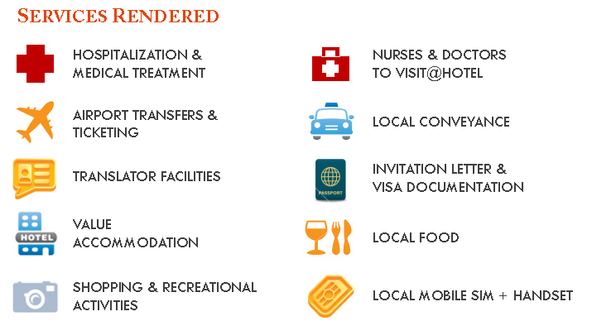
AADI MediTour is dedicated to fulfil all the special needs and requirements of international patients. In order to provide a highly specialized service we offer end-to-end patient services of world-class quality.

These services include:
- Free pick-up and drop from airport
- Quick doctor’s appointments
- No waiting time and treatment starts from Day 1
- Coordination of all admission purposes
- Cost estimates with doctor’s detailed profiles
- Nurses and doctors to visit at hotel/guest house
- Remote consultations via Doctor@Net

Indian Patients
Due to the incredible diversity in the Indian population, every patient is neither able to afford the most sophisticated expensive treatments nor get access to good medical care facilities, especially in the rural areas. Hence, we at AADI MediTour aim at providing the best possible treatment at the best possible price.
With our own healthcare facility – CHIKITSA Multispecialty Hospital – we can provide treatment to a vast majority of population. In addition, we assist patients who face problems with finding the right doctor, right treatment and right price for the treatment. Whether a patient is located in a metro or in a village, we believe that every patient can benefit from our services in the medical field, which include:
- Medical Care
  - Studying the medical case of the patient
  - Suggesting the appropriate doctor depending upon patient’s affordability
  - Assisting in quick doctor’s appointment
  - Accompanying during the tedious admission process
  - Helping with insurance matters
- Travel & Accommodation
  - Book tickets for both train and air
  - Value accommodation starting from INR 250/- per night
- Pick-up and drop from airport/railway station
- Local conveyance
- Local mobile number
- Nurses and doctors to visit at hotel/guest house
- Remote consultations via Doctor@Net

Why AADI MediTour?

AADI MediTour is an organization that provides single-window solutions to its patients and helps them obtain top quality medical care and a comfortable stay at affordable prices. We are dedicated to be with you at each stage, right from decision-making to its implementation and the after-service.
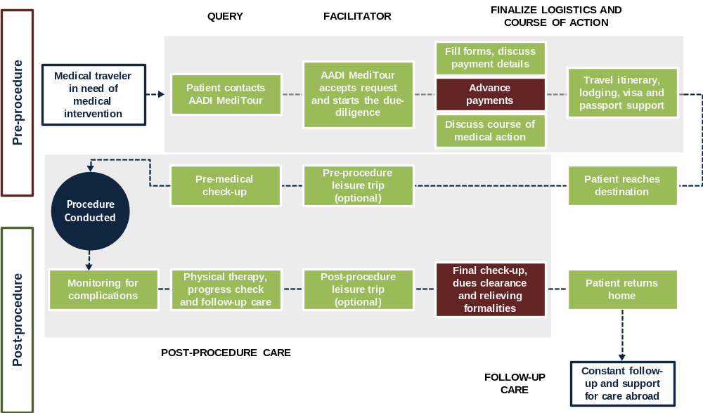
Right from the first step, our medical staff believes in devoting completely at your disposal. We take time to listen to you and evaluate your medical condition, suggest the appropriate course of treatment, assist in finalizing the travel documentation, make the most comforting lodging and logistic arrangements, conduct pre- and post- medical check-ups and finally, constantly follows-up to maintain long-term relationships with our clients. In a nutshell, we are meant to be for those people who travel to receive medical care and still want a homely environment.

In addition, we have on board country’s best medical consultants who help us identify unexplored medical service providers, and an advisory board of top medical practitioners who assist in finalizing the best course of treatment to the patient, by selecting the finest physicians and the best- in-class medical facilities.

Also getting popular today are the non-conventional therapies such as Ayurveda, Naturopathy, Yoga, Spa, Aroma therapy, Flower therapy etc. Not only that they are effective alternates to the allopathic therapies in certain fields, they also complement the established procedures. At AADI MediTour, we ensure all such treatments are carried out by well-trained and qualified professionals.

And last, but not the least, AADI MediTour also organizes leisure tours that help enhance patients’ rejuvenation in a unique manner. With its rich and diverse cultural heritage, countries such as India, Thailand, South Africa & Turkey, are replete with exotic tourist spots, such as the Taj Mahal – one of the wonders of the world – is just one to name.

Unique Product Offerings
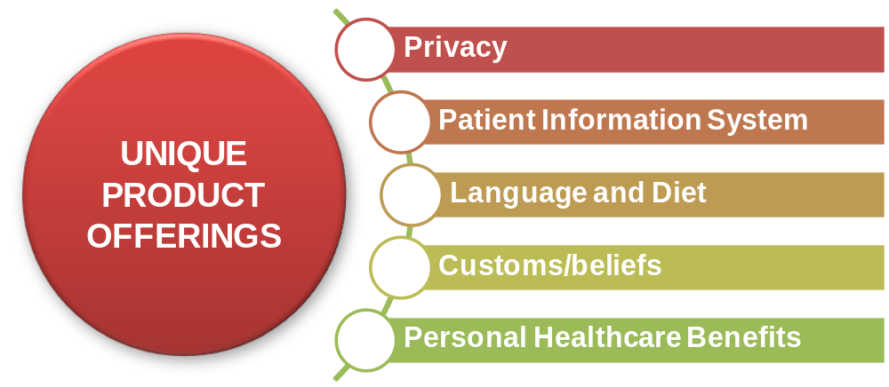
Privacy
We at AADI MediTour completely understand that your personal, medical and other health information is private and should be secured. For this, we protect all the personal details and prohibit from sharing it with a third-party, without your consent. This primarily includes:
- Medical and other health information that is shared with doctors, nurses, and other health care providers
- Various conversations/meetings being conducted with the consulted doctor(s)/nurses and others
- Personal details
- Other health/personal information that may be provided and not mentioned above
- Billing information

Patient Information System
With the advent of Health Information Technology in the US, we have developed a tool – known as the Patient Health Record – that annals patients complete medical history. For every patient, we maintain a comprehensive database that records information including demographics, medical history, medication and allergies, immunization status, test results, and billing information. Such system can provide long-term storage of important information, which could be quite cumbersome in case of piling physically. Also, it provides quick access to key medical information to analyze cases requiring future interventions.

Language and Diet
We keep in mind that diets vary from patient to patient, across different religions and different times of year. For instance, we have the provision of Halal food for patients & their families coming from Middle Eastern and Arabic countries. At AADI MediTour, we make sure that every patient is uniquely treated keeping above in mind.

Custom / Beliefs
We are fully equipped with providing interpreter support, which is essentially for patients traveling from all parts of the world. In addition, we are prepared to provide round-the-clock translation service, which is important for effectively communicating medical terminology between the patient and physician. We also recognize and address the heterogeneity of all patients, and respect their cultural sensitivity. Different parts of the world have different customs and beliefs, which must be adhered to for achieving a favorable output. We consider every aspect of individual requirements and always attempt to fulfill them in the best possible manner.

Personal Healthcare Benefits
We at AADI MediTour believe that one of the most important aspects of the patients’ experience is the follow-up care after a procedure is conducted. We organize leisure tours and plans trips for non-conventional/alternative therapies that could enhance patients’ rejuvenation in a unique manner.

CHIKITSA Multispecialty Hospital
‘CHIKITSA’ Multispecialty Hospital is a center providing comprehensive Medicare by senior and reputed specialists under one roof. It is located in the prestigious South Delhi colony of Saket & is 8 km from the International Airport in Delhi.

The management of the hospital consists of senior medical doctors, who provide expertise in various branches of modern medicines, such as surgery, gynecology and obstetrician, pediatrics, orthopedics, ophthalmology, neurology, dermatology, ENT, psychiatry, dental care, pathology, radiology, anesthesia, etc.

The patient rooms are spacious, airy, and comfortable providing bed strength of 25, including transient beds. Round the clock Medicare services including 24 hour emergency service is provided by doctors and qualifies nurses to look after the needs of patients. In addition, a full time pantry runs in the nursing home premises.

The hospital consists of two operation theaters and labor room with total emphasis on 100% asepsis. These are fully equipped in all respects and can cater to any kind of major, minor, or emergency surgeries. Recovery beds are provided for patients requiring a short stay in the hospital and for disaster management in case of emergencies. CHIKITSA also possess facilities for laparoscopy procedures for diagnostic as well as therapeutic purposes.

Moreover, CHIKITSA is proficient enough to undertake special care of ‘burns’ cases. Super specialty of cosmetic and plastic surgery is also practiced. In addition, pre- and post- operative care for kidney transplant is provided which lowers the high costs of total kidney transplant.

A fully equipped modern laboratory with a computerized auto-analyzer is already functioning under an experienced senior pathologist. The laboratory carries out all kinds of hematological, stool, urine, serological, microbiological, histo-pathological and cytological tests. Executive medical check-ups are also undertaken at our center under various packages offered to suit the various needs.

It also provides all types of Radio diagnostic facilities. Besides the routine X-Ray, special X-Rays, such as IVP, OCG, Barium Meal & Barium Enema, etc., can also be done. ECG and ultrasound facilities are also available in CHIKITSA.

A chemist shop is functional at CHIKITSA ensuring a supply of drugs for both indoor and outdoor purposes. For further convenience, this is soon going to be a 24-hour chemist shop, which will go a long way to help.

Immunization, Phototherapy & special care for newly born is being given under special guidance of pediatricians. Physiotherapy is also provided. CHIKITSA also undertakes drug addiction cases under the special care of psychiatrists.

Multispecialty at CHIKITSA Hospital
Medicine Gynecology and Obstetrics Surgery
Psychiatry Eye Care ENT
Pediatrics Dermatology Orthopedics
Pathology Radiology Ultrasonology
Dental Physiotherapy

Super-specialty at CHIKITSA Hospital
Cardiology Pediatric Surgery Gastroenterology
GI Surgery Endocrinology Urology
Neurology Neurosurgery Geriatrics
Vascular Surgery Hair Transplant Burns and Plastic Surgery
Scar Removal Infertility Treatment Laser Eye Surgery
Laparoscopic Hysterectomy LASIK for glass removal Corneal Transplant
Squint Surgery PHACO emulsification Surgery Glaucoma Treatment
Occuplasty Orthodentistry Facio Maxillary Surgery

CHIKITSA Hospital has exclusive tie-ups with leading diagnostic centers and hospitals for any specialized extension of medical care required for our patients. These facilities include:
- Transfer of serious patients to I.C.C.U
- MRI and CT Scans including CT guided investigations
- Bone Densitometry and Mammography
- Specialized chromosomal and other laboratory investigations
- Non-invasive Cardiac investigations, such as Echo, Color Doppler, TMT, etc.
- Pulmonary function tests
- Plastic and Cosmetic surgery
- Specialized Nursery care for newly born
- Direct referral for cases requiring Angioplasty, etc.
- Pre- and post- kidney transplant care
- Knee replacement operations

Salient Features
- Registered and recognized by Delhi Administration
- Recognized center for MTP and family welfare activities
- Approved center for Tuberculosis under National Health Program
- Comprehensive Medical check-up schemes
- On panel of all major Insurance companies and Third-party Administrators (TPAs)
- Medical check-up for employees at job entry
- Free health check-up camps
- Free T.B. medicines under Health Program
- 24 hour ambulance services available
- Drug de-addiction case treatment undertaken
- In-house pharmacy for medicines to indoor patients
- Chemist shop in the premises

Doctor’s Profiles

Cardiology & Cardiac Surgery
Dr. Ashok Seth
Dr. Balbir Singh
Dr. Bhaba N. Das
Dr. Colin John
Dr. Devi Prasad Shetty
Dr. Ganesh K. Mani
Dr. Inderjit S. Virdi
Dr. K. S. Dagar
Dr. K. S. Iyer
Dr. Naresh Trehan
Dr. Praveen Chandra
Dr. Praveen Kumar
Dr. R. R. Kasliwal
Dr. Rakesh Mahajan
Dr. T. S. Kler
Dr. Viveka Kumar
Dr. Z. S. Meharwal

Endocrinology
Dr. Ambrish Mithal
Dr. Anoop Mishra
Dr. S. K. Wangnoo
Dr. Sujeet Jha

Paediatric Cardiology
Dr. Colin John
Dr. Devi Prasad Shetty
Dr. K. S. Iyer
Dr. Raja Joshi
Dr. Vikas Kohli
Dr. Viresh Mahajan

Aesthetic and Reconstructive Surgery
Dr. Ashok Raj Koul
Dr. Kuldeep Singh
Dr. Rakesh K. Khazanchi
Dr. Rashmi Taneja
Dr. Shahin Nooreyezdan
Dr. Sunil Choudhary

Respiratory, Critical Care & Sleep Medicine
Dr. Avdhesh Bansal
Dr. Hemant Tiwari
Dr. Sanjay Sobti
Dr. Vivek Nangia

Oncology
Dr. A. K. Anand
Dr. Harit Chaturvedi
Dr. Harsh Dua
Dr. Girish Sadam Prabhakar
Dr. G. K. Jadhav
Dr. K. K. Pandey
Dr. Moni Abraham Kuriakose
Dr. P. K. Das
Dr. Paul Salin
Dr. Pramod Subash
Dr. Prasad Raj Dandekar
Dr. Rajeev Kumar
Dr. Sapna Nangia
Dr. Tejinder Kataria
Dr. (Col) V. P. Singh

Bone Marrow Transplant
Dr. Ashok Vaid
Dr. Rakesh Ojha
Dr.Sharth Damodar

Minimal Access, Metabolic & Bariatric Surgery
Dr. Pradeep Chowbey

Neurosciences
Dr. (Prof.) A. K. Banerji
Dr. Ajaya N. Jha
Dr. Anoop Kohli
Dr. Banu Prakash A.S
Dr. Bipin S. Walia
Dr. J. D. Mukherjee
Dr. Kiran. M
Dr. Komal Prasad C.
Dr. Mukul Varma
Dr. R. Ganesh Prasad
Dr. Rajendra Prasad
Dr. Rakesh Aggarwal
Dr. Rana Patir
Dr. Sanjay Gupta
Dr. Shakir Hussain
Dr. Thimappa Hegde
Dr. Varindera P. Singh
Dr. Vikas Gupta
Dr. Vinit Suri
Dr. Vipul Gupta
Dr. Yashbir Dewan

Orthopaedics
Dr. Ashok Rajagopal
Dr. Chandrasekar Chikkamuniyappa
Dr. Gowrishankar Swamy LG
Dr. H. N. Bajaj
Dr. Harsh Bhargava
Dr. Harshavardhan K Hegde
Dr. K. B. Attri
Dr. P. S. Maini
Dr. (Prof.) P. K. Dave
Dr. R. K. Sharma
Dr. S. K. S. Marya
Dr. Sharan S. Patil

Paediatrics
Dr. Anurag Krishan
Dr. P. N. Dubey

Obstetrics & Gynaecology
Dr. Geeta Chadda
Dr. Lalita Badhwar
Dr. Sushma Sinha
Dr. Urvashi P. Jha

IVF
Dr. Anuradha Kannan
Dr. Hrishikesh Pai
Dr. Kaberi Bannerjee
Dr. Sushma Sinha

Kidney & Urology
Dr. Akhil Mishra
Dr. Anant Kumar
Dr. Ashok Sarin
Dr. Narmada Prasad Gupta
Dr. Pratap B. Singh
Dr. Vijay Kher

ENT
Dr. K. K. Handa
Dr. Sanjay Sachdeva

Gastroenterology
Dr. Ajay Bhalla
Dr. Kenneth D' Cruz
Dr. Rajesh Puri
Dr. Randhir Sud
Dr. Sanjay Sikka
Dr. Vivek Raj

Ophthalmology
Dr. Mahipal Sachdeva

Dental
Dr. D. K. Malhotra
Dr. Varun Malhotra

Liver Transplant Surgery
Dr. Arvinder S. Soin
Dr. Ashley D’Cruz
Dr. Kenneth D' Cruz
Dr. Subhash Gupta

Kidney Transplant Surgery
Dr. Isthiaque Ahmed
Dr. Lyold Vincent
Dr. Nithin Hegde
Dr. Pratap B. Singh
Dr. Rajesh Ahlawat
Dr. Suresh K. Rawat
Dr. Vijay Kher
Dr. Vipin Arora

Heart & Lung Transplant Surgery
Dr. P. V. Rao

FAQs
Medical
Do you only provide services to patients traveling from abroad?
No. AADI MediTour is dedicated to deliver a broad array of services to all patients, who travel both domestically and internationally, including ‘In-bound’: Patients who come to India, ‘Inter-bound’: Patients who travel to other countries, and ‘Intra-bound’: Indian patients who travel within. In addition, we provide medical counseling and travel arrangements for people located in the NCR region, who especially want to avail medical care in NCR.

How can I connect with a doctor located in the destination country?
AADI MediTour will help facilitate the initial consultation between you and the doctor. Additional correspondence before traveling can be conducted via phone, email, and/or video-conference, if desired.

What services are included in my medical estimate?
Our medical packages include hospital fees, physician charges, an initial consultation, medical tests as specified, anticipated meal and accommodation charges based on the expected hospital stay, registered nurse coverage and a follow-up consultation after your medical treatment is complete. Each quote will accompany specific terms and conditions. Separate quotes will be provided for travel-related charges, such as flight, transfers and accommodation. Kindly note that the costs such as medical procedure, travel, etc., are only applicable for 30 days, and may change in case of elongated delays.

How important is accreditation to evaluate a medical facility?
Accreditations such as Joint Commission International (JCI), ensures that the hospitals adhere to highest standards of safety, care and sanitation. Joint Commission International (JCI) is the international arm of the US-based accreditation body Joint Commission on Accreditation for Healthcare Organizations (JCAHO). In JCI, there are 565 standards divided into 197 core standards that must be met to achieve accreditation and 368 other standards that lead organizations to best practice levels. These standards are further divided into 1,033 measurable parameters, which focus on aspects, such as patients’ safety, quality standards, medical technology, facilities, physicians’ credentials, etc. Considering this, AADI MediTour has partnered with the state-of-the-art hospitals and medical care providers, which provide best-in-class services. We can provide you with the most updated photos of hospital interior, patient suites, operating rooms, etc., while sending you the detailed packages.

Travel & Lodging
How many days prior to the operation do I have to leave?
Your departure will depend upon the medical procedure, whose details will be provided to the medical service provider. Typically, it is one day.

How will I contact you when arriving at the destination city?
AADI MediTour ensures to pick a patient / family from the airport / station. They will be transported to the lodging facility / hotel, where you will be given a detailed itinerary of your stay. In addition, we can also provide you with a temporary local mobile phone connection, which you can carry around the country.

How do I manage language difficulties or translation problems?
Your physicians and nurses speak fluent English so patient should have no trouble communicating with nurses and physicians at our partner hospitals. All patients can reach AADI MediTour through our website, email or direct phone line. Additionally, AADI MediTour offers local guide in selected cities to help you in any translation and logistic services

Payment
How do I make the payments?
No payments are made in advance. AADI MediTour does not charge any service fee from the patients. All the treatments are conducted at hospital-printed prices. The patients pay directly to the hospital, taxi, hotel, etc., for their services.

How are the payments handled?
AADI MediTour India is not the medical provider and cannot accept payment for your medical expenses. You will be required to make payment as per hospital policy. Usually, this involves paying a deposit prior to undergoing any diagnostic tests and / or procedures. A final bill will be presented to you prior to discharge from the hospital.

What if I must postpone my trip due to personal reasons?
The packages provided are valid for 30 days only. In case, the patient defers the trip by more than 30 days, a new quotation is provided. Typically, we require at least 2 days’ notice period from the patient, before she/he starts the journey.

Contact Us

India
AADI MediTour India
CHIKITSA Multispecialty Hospital
B-4 Saket | New Delhi | 110 017 | India
Ph: 0091 98739 24284; 0091 97111 12808
Email: info@aadimedicaltourism.com; contact@aadimedicaltourism.com

Uganda
Mr. Emmanuel Odongo
Country Head, Uganda
House F | Mpererwe Estates | Kampala | Uganda
Ph: 00256 7036 02399
Email: eodongo@aadimedicaltourism.com

Kenya
Mr. Simon Simbi / Ms. Bernice Simbi
Brick Court | Mpaka Road | Westland
Nairobi | Keyna
Ph: 00254 733203020; 00254 720219832
Email: prosperityinsurance@hotmail.com

Our associates are located in Nigeria, Tanzania, Ghana, Ivory Coast, Iraq, Afghanistan, and Nepal. Patients from these countries can send their queries directly at query@aadimedicaltourism.com. Our associates will contact you within 24 hours.

